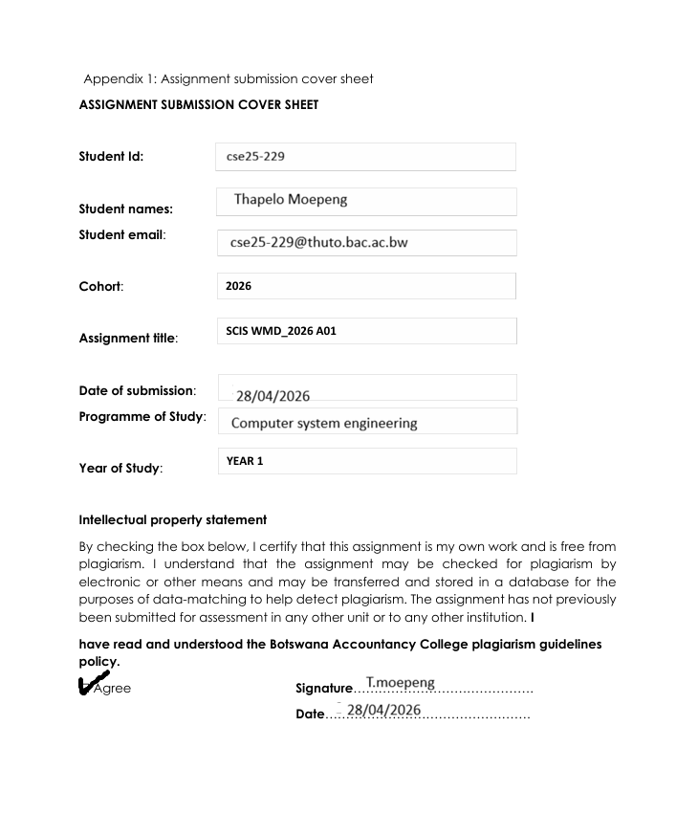

Part A – Website Specification Document
Task 2
- Website Specifications:

- State the website objective, its goals in relation to the business.

The main objective of the website is to:

- To showcase different places of attractions in Botswana which may attract tourists to visit the country of Botswana and this will eventually help boost the generation of revenue in the department of tourism.

- As more tourists are attracted, this would help local businesses such as hawkers, retailers, hotel owners and tour guiders generate more income through selling local products and providing services such accommodation and tour guides.

- State the target audience, showing their demographics and technical aptitude.

Demographic

- Age: 16+ years
- Gender: Both male and female
- Location: Local and international tourist
- Income level: People who afford to travel

Technical aptitude

- Mostly people who use mobile phones and social media
- People who can Browse Through the website and search information

- You must identify the type of website or content you will be designing for the users

This is a special interest website because it focuses on a specific topic which is tourism and at the same time it’s a publishing website simply because it provides information and content about tourism for users to read and learn from.

- Information Design & Taxonomy:
Information Design
This website will consist of the following pages:

- Home/index page: This page serves as the entry point of the website which consist of four sections which are Our destinations, Events, Culture and Activities. Under Our destination section, there would be a slideshow which showing highlights of top tourism destination. Under Events would also have a slideshow showing major upcoming events. Under Culture there would be a links that takes user straight to Culture page were they well get full details of what the page contains. And lasty the well be the activity section which also have a slideshow which would show major activities done in tourism destinations.

- Destination page: This page will have a list of different types of Tourist sites such as game reserves, cities, pans, national parks, historical sites and wetland/delta and in each of these sites there would be a collection of different places in which a full description would be provided about each place in it.

- Culture page: This page consists of three main categories which are Food, music, tradition section. Under food category there would be a listing of different types of food found in Botswana across various cultures, including a description page of each food. Under music category there will be a listing of artist who produce traditional songs and each one of them will have their own description page. And lastly under tradition category there would be a listing of different cultural traditions in Botswana. Under each tradition there will be topic that will be covered like practices, customs and beliefs which would be done own their own description pages.

- Activities page: This page would consist of four main categories of activities which are adventure, desert, water and nature and wildlife activities. Each activity would have its own description page

- Event page: This page would consist of three main categories of events which are cultural, sport and music and entertainment event. This category gives users an overview, allowing them to browse through multiple events at once. Each event would have its own description page that provides specific information about it.

- Travel information page: It would consist of three main category which are Transport, Safety information and best time to visit. Under transport there would be a list of types of transport that one would use to visit places of tourism across Botswana and under safety information, there would be a listing of different guidelines and safety precautions that explain how tourist should behave and stay safe when visiting tourism destinations. Lastly under best time to visit there would be a listing of different factors such as weather condition, seasonal overview, events and festivals that would help tourist plan and know the best time to visit a place of tourism depending on the listed factors.

- Feedback page: on this page the users will share their opinions, suggestions, or complaints about the website or its service.

Every page on the website, except for the feedback page, will have the same layout. For example, there will be a sidebar on the left that allows quick access to other pages. The navigation bar at the top will be consistent across all pages, and the footer will also have a uniform design throughout the site consisting of the address, location, feedback section, and social media links for the ministry of tourism.

Taxonomy

This website will use a Hierarchical taxonomy as the main structure and would be supported by a web taxonomy through interlinked related content. This means under hierarchical taxonomy

Storyboard flowchart
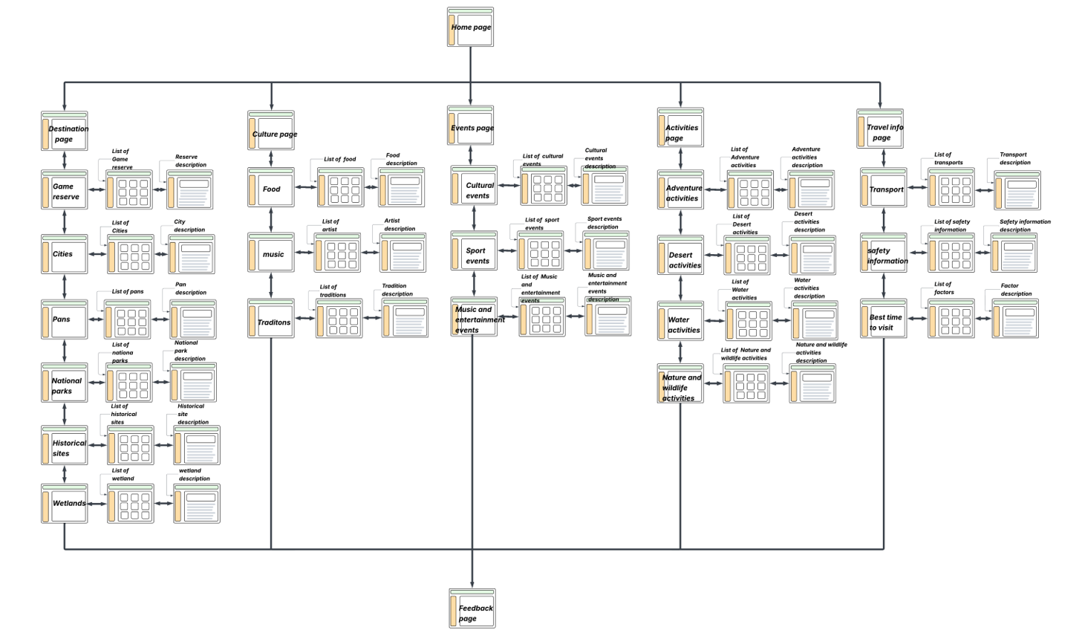

4.Technical Brief:
- Technologies to be used:

- HTML – to check the structure of the web pages
- CSS-to design and style the website layout

- Software tools:

- VS code-for writing code
- Chrome-for testing and viewing the website
- Github-for storing and managing the websites files
- Lucidchart-for designing wireframe

